‘Peg’ and ‘Depeg’ are terms used in cryptocurrency to describe the relationship between digital asset and traditional asset such as fiat currency

‘Peg’ refers to a situation in which a crypto is pegged to the value of a traditional asset such as the USD at a fixed exchange rate. This means that the value of the cryoto remains stable regardless of the fluctuations in the cryptocurrency market

‘Depeg’ refers to the opposite scenario in which the value of the crypto is no longer tied to the value of the traditional asset and begins to fluctuate independently of that of the traditional asset. This can happen if the exchange rate between the cryptocurrency and the traditional asset changes or if the cryptocurrency market values experience significant fluctuations.

In summary peg refers to the stable exchange rate between a cryptocurrency and a traditional asset, while depeg refers to a situation in which the exchange rate becomes unstable or the cryptocurrency begins to fluctuate independently of the traditional asset.

PSM - Peg stability module

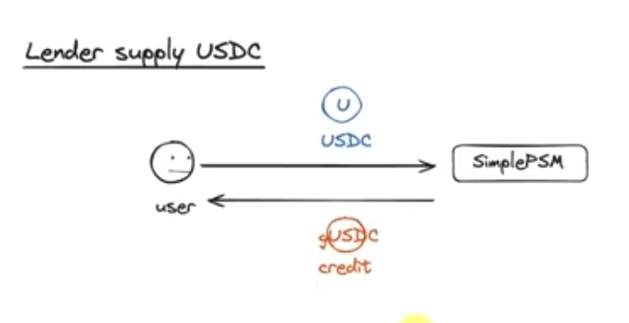

Credit token is a rebase distributor token. Deals with the total supply of token keeps. Keeps changing over time. Everytime there's a profit or a loss it targets a different total supply and over time the total supply tries to move towards that target. The credit tokens acquire interest or or yield but their value is supposed to be tied to the collateral token so that brings up the question how this interest is being paid to the lenders? The answer to that is rebasing. For example if I hold 100 gUSDC tokens and these tokens are staked or lended somewhere, the more time paases I will get 5 % as per my or my staking guild's rate of interest as in the form of more gUSDC tokens. The value of the token will not go up in price but my balance will increase over time. That's what rebasing means.

Wonderland time (?)

Olympus the protocol(?) - these were some of the first big protocols to introduce rebasing in the summer of 2020-21.

Basically rebasing means that you get more balance in terms of the corresponding token as your interest of lending or staking yield, yield farming etc.

Algorithmic Peg

To keep an algorithmically stable coin connected/pegged to the USD. So far every coin that uses this method has slightly different way of execution, usually using minting and burning process

StableCoins:

USDT/Tether (by Tether) = 1USD

DAI (by MakerDao) - not managed by a private company. Collateralized by a mix of assets

USDC (by The Circle Foundation)

Small market cap = High volatility

Stablecoins are an attempt to create a cryptocurrency that isn't volatile. The value of a stablecoin is pegged to that of a real world currency which is called a fiat currency. These coins allow for the convenience of cryptocurrency which means fast settlement and fewer regulatory hurdles along with stability of fiat currency.

Main use of stablecoins nowadays is iron cryptocurrency exchanges. Using them traders can exchange volatile cryptocurrencies for stable cryptocurrencies to lower their risk. This method is extremely popular among crypto-only exchanges because they don't allow cryptocurrency for fiat currency due to regulations.

Another great advantage is that you can move funds between exchanges relatively quickly since crypto transactions are faster and cheaper than fiat transactions. The options for such a fast settlement makes arbitraging more convenient and closes the price gap that is found in crypto exchanges. So now stable coins are more utility coins for traders than an actual medium of exchange.

To maintain a stablecoin peg

1. By creating TRUST (COLLATERAL) that the coin is actually worth what it is pegged to. For example if the market doesn't believe that 1 USDT = 1 USD then it will immediately crash.

In order to maintain this trust the company backs its coins with some sorts of assets. Its proof that the company is worth its word and the coins are actually pegged to the corresponding amount.

Example- DGX token is said to be backed by gold

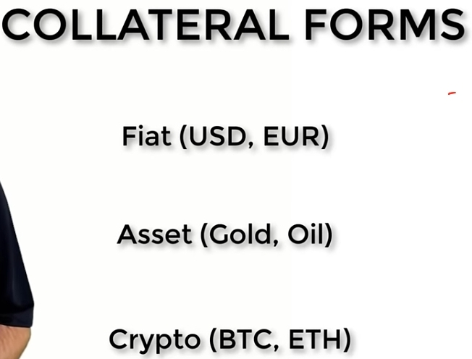

Some coins are backed by one or more cryptocurrencies. These are much easier to audit since a company’s balance can be viewed on the blockchain.

1. By manipulating COIN SUPPLY (ALGORITHMIC), also known as an ALGORITHMIC PEG where the company writes a set of rules i.e. a smart contract that controls the amount of stablecoins in circulation depending on the coin's price.

For example imagine a cryptocurrency pegged to the USD. Now if many people were to start buying the coin then its price would rise and the peg would be broken. To prevent this from happening new coins are issued. The increase in supply alleviates the rise in demand while maintaining the peg. In case of many people selling the coin to battle the drop in price, coins are removed from the supply to hold the price peg to the USD.

Algorithmically pegged coins don't hold any assets as collateral. The smart contract managing the coin acts as the central bank. It tries to manipulate the price back to the peg by changing the money supply.

PEOs and CONs:

1. FIAT COLLATERAL PEG
2. PROs:
3. Highest degree of certainty to stablecoin holders.
4. CONs:
5. From the company’s standpoint the asset is frozen and cannot be used for anything else i.e. the capital sits ideal.
6. Risk of embezzlement.
7. Risk of sudden closing of the company’s bank account.
8. Required proof of solvency. Hard to prove that the company owns enough assets to really back the amount in circulation.

2. CRYPTO COLLATERAL PEG

1. PROs:
2. Easily audited since the collateral is viewable on the blockchain.
3. No assets required. Company doesn't need to hold any asset on hand.
4. CONs:
5. Extremely volatile collateral
6. That's why a premium is needed. In many cases the company will hold a 150% or more of the collateral needed to make up for possible drops in the cryptocurrency prices.
7. Questionable solution about real life implementation since manipulating the money supply isn't a guarantee that the peg will hold.

Stablecoin Business Models:

1. Charge a fee for trading the coin.
2. Use the coin as a marketing channel to raise awareness about the company itself and other services it offers.
3. Housing, Gemini, Coinbase and Circle are exchanges that have created their own stablecoins in order to attract more users to their platforms and allow easier transitionof funds within and between exchanges.

Some Popular StableCoins in Use Today:

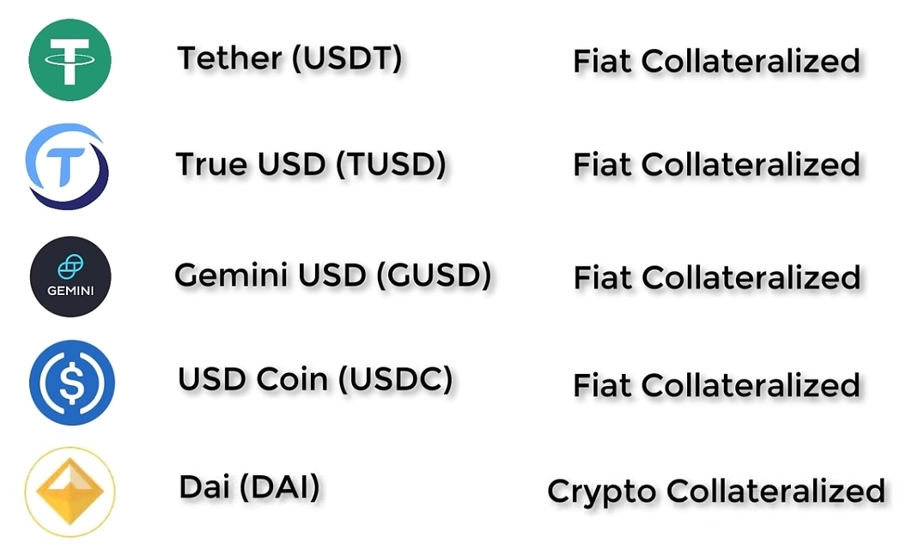

Resources

<https://youtu.be/omWpeh8ZKmU?si=_IZgGdnOsObQN_-m>